

Start



Enter

Programming



Auto

/

Manual



Low LLC



Check

Temperature



Heater ON



Display

“Heating”

No

Manual

High

Low



High LLC



Display

“Ready”

High

High



1



1



1

Low

Low



1



2

Auto



1



5



2



Low LLC



Energize Fill Valve



Display

“Filling”



Energize Heater



Temperature



Display

“Heating”



High LLC



2

Low



Energize Fill Valve



Display

“Filling”



2

Low

High

Low

High

High



2



Display

“Start”



3



3



Select Heater

Upper



Energize

/

de

-

energize

Upper heater



Change upper

heater icon to show

active state



Select Heater

Lower



Energize

/

de

-

energize

Lower heater



Change lower heater

icon to show active

state



Select Batch Size

High

High

Low

Low



Display appropriate

batch size

High



3



3



3



Start Brew

?



3

Low

Low



4

High



4



Display

“Stop”



Stop Pressed

?



Clear Display



2



Activate

Fill valve



Brew time

reached

?



Clear display

High

Low

High



2



4

Low

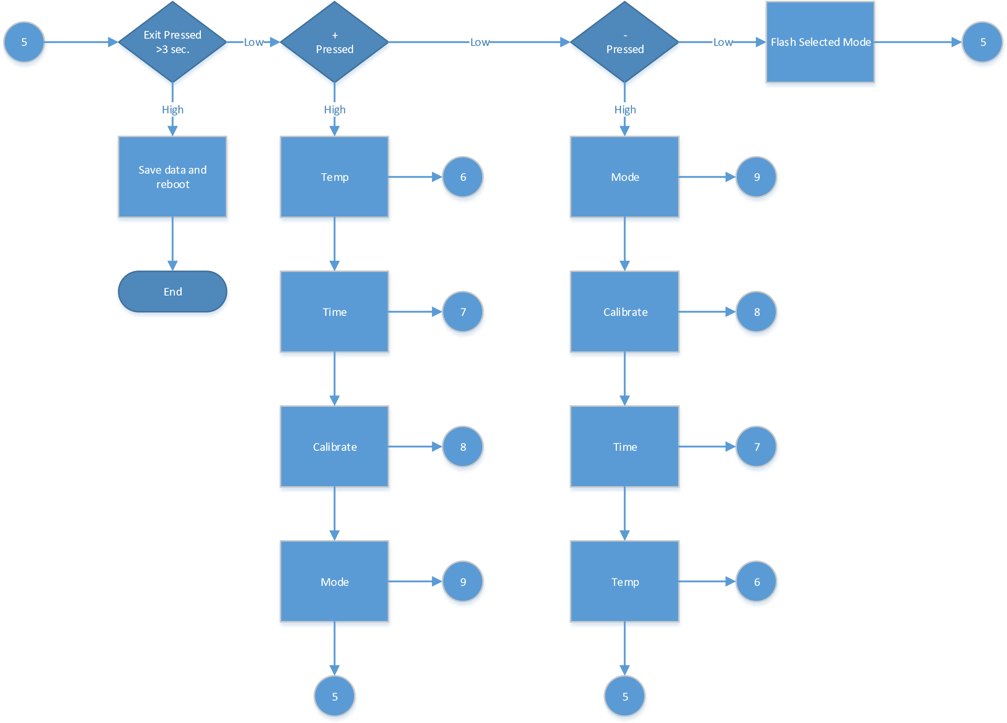



6



Exit

Pressed

<

3

sec



5



+

Pressed



-

Pressed



Increment

Temperature



Display

Temperature



Decrease

Temperature



Display

Temperature



6



6



6

Low

Low

High

High

High



Exit

Pressed

>

3

sec

.



Save data and

reboot



End

Low

Low

High



7



Exit

Pressed

<

3

sec



5



+

Pressed



-

Pressed



Increment

Time



Display

Time



Decrease

Time



Display

Time



7



7



7

Low

Low

High

High

High



Exit

Pressed

>

3

sec

.



Save data and

reboot



End

Low

Low

High



8



Exit

Pressed

<

3

sec



5



+

Pressed



-

Pressed



Increment

Calibration



Display

Calibration



Decrease

Calibration



Display

Calibration



8



8



8

Low

Low

High

High

High



Exit

Pressed

>

3

sec

.



Save data and

reboot



End

Low

Low

High



9



Exit

Pressed

<

3

sec



5



+

Pressed



-

Pressed



Increment

Mode



Display

Mode



Decrease

Mode



Display

Mode



9



9



9

Low

Low

High

High

High



Exit

Pressed

>

3

sec

.



Save data and

reboot



End

Low

Low

High